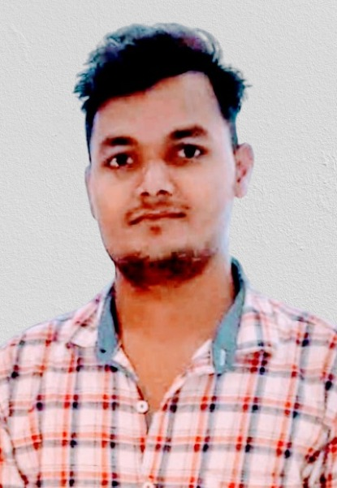
Shalabh Dwivedi
Contact no: 9695328630
Email: shalabh132@gmail.com
OBJECTIVE
To work in innovative and challenging environment that could enhance and improve my skills, knowledge and to grow with the company.

CAREER SUMMRY
- I have worked in Integrity telenetworks Pvt. Ltd as a Field Engineer for NOKIA india ltd. for Bharti airtel & RJIL project. From December 2016 to December 2020 .

- I have worked in fiber home for 1 year from Fab-2021 to Jan-2022 in BSNL from. 2021
- I have worked in NOKIA for VI as a Tx. Engg. Role of STCS from march 2022 .

- I have worked in AIRTEL for as a ISP Engg. Role of V5 GLOBLE from 2024.

EDUCATIONAL QYUALIFICATION
- Bachelor of technology in Electrical Engineering (2013-2017)
From SIET Allahabad.
TECHNICAL STRENGTHS
- Understanding of Transmission Equipment Such as Add
Drop Multiplexers.
- Transmission SDH, DWDM.
- Operation and maintenance ( Transmission & utility).
- Ability to create Network Links between the equipment.

Knowledge about NOKIA (alcatel-lucent) Transmission mux. As PSS-24x, PSS-64, PSS-32, PSS-8, PSS-4, (Low cost DWDM), 1626 , DXC 1678, (ECI-NPT-1010/20/22/50/1200/1300/ BG/20/30/40/64,XDM),(HUAWEI- X4/8/16,DWDM). CISCO: CIENA : OLT MUX: ONT
NOKIA & CISCO & CIENA ROUTER,S

SKILLS
- Hands On Experience of I&C of Transmission Equipment.
- Implementation with Specification, SDH, Ethernet Tester,
BER Meter, Spectrum Analyzer.
- Migration of Traffic over transmission equipment.
- ATP

INDUSTRIAL TRAINING:
- Industrial training at PRIME CONNECT TECNOLOGY Pvt. Ltd. In the field of Transmission as Field engineer for Installation & Commissioning.

MAJOR PROJECT:
TECONZ INFOTEC in GSM &3G.
AREA OF INTEREST:
- Basic Electrical.
- Electronic Instrumentation.

SOFTWARE PROFICIENCY:
- MS-OFFICE (Word, PowerPoint, Excel).

PERSONAL SKILLS:
Ability to deal with people diplomatically, willingness to learn new things, comprehensive problem solving abilities, effective verbal and written communication skills, ability to lead team and good understanding of relationship and management.

PERSONAL PROFILE:
Name : Shalabh Dwivedi
Father s name : Prakash Chandra Dwivedi
Nationality : Indian
Date of Birth : 08-06-1995
Languages : Hindi(R/W) and English(R/W)
Current Organization : V5 GLOBLE
Current Location : Prayagraj
Total Experience : 7+ Years.
Relevant Experience : 6 year
Notice Period : 15 To 30 Days
Qualification : Bachelor of technology
Contract No : 9695328630
Email id : shalabh132@gmail.com
Permanent address : Vill-Dubaha, Post-Dubaha, Dist. - Allahabad, UP (212107)

DECLARATION: I hereby declare that the above particulars furnished by me are true to the best of my knowledge and belief.

Place: Prayagraj Yours Faithfully,
Date: Shalabh Dwivedi

